**REPORT OF PROJECT**

**(UNIT CONVERTER)**

**INTRODUCTION** **–** Unit Converter supports conversions between combinations of units. The input and the result can consist of various units and this conversion is enumerated in one step, e.g. a length measured in yards, feet and inches into the length in meters and centimetres.

**AIM –** To easily calculate the conversion of different units easily in one step.

**SUPPORTED CONVERSION TYPES –**

1. Length
2. Temperature
3. Weight
4. Area
5. Volume

**HEADERS FILES –**

(1) iostream : iostream stands for standard input-output stream. This header file contains definitions to objects like cin, cout, cerr etc.

(2) stdlib.h : stdlib is the header for general purpose standard library of C/C++ programming language which includes functions involving memory allocation, process control, conversions and others.

**REQUIREMENTS –** Code Blocks and a suitable C++ compiler.

**CODING –** The file of source code has been uploaded separately.

**TESTING –**

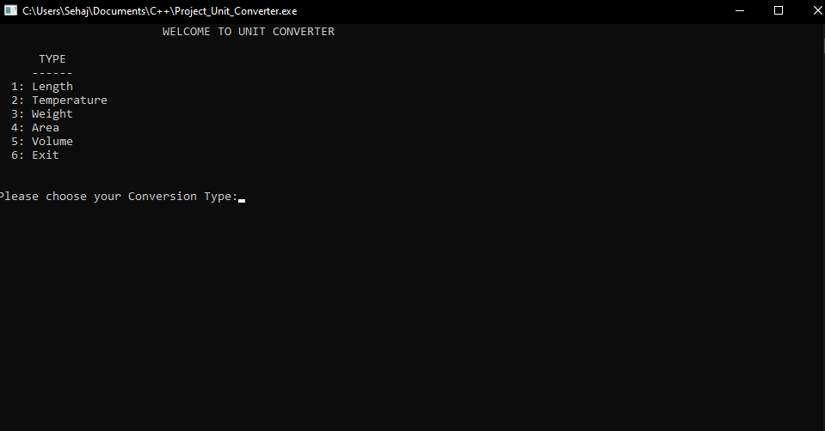

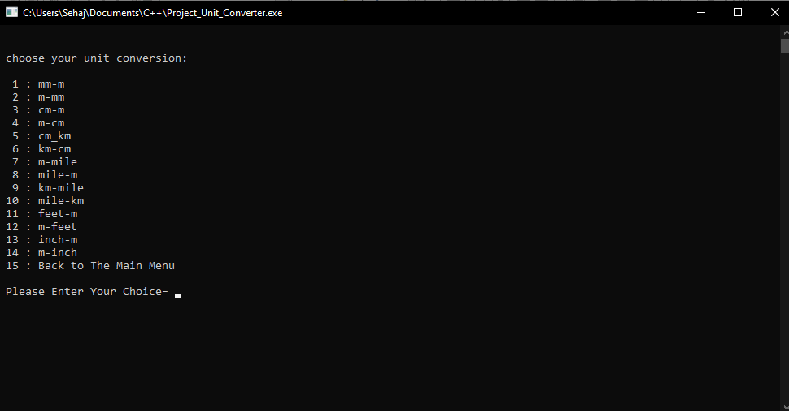

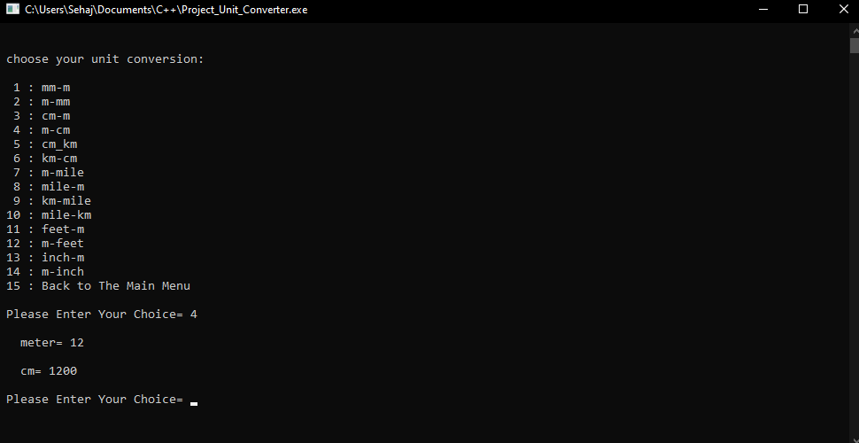

**APPLICATIONS –**

1. Can be used anywhere and anytime
2. Supports multiple unit conversions
3. User-friendly
4. Conversions can be enumerated in one step

**PROJECT CONTRIBUTORS –**

* Sehajveer Singh (CO19357)
* Taranjeet Singh (CO19365)